Old Windsor Parish Council
MINUTES OF THE COUNCIL MEETING
HELD ON WEDNESDAY 15^{h} JANUARY 2025 AT 7.30 P.M

PRESENT: Cllrs, J. K. Dawson, M.V. Beer, M.P. Bennett, J.A. Blackmore, D. Boresjo, W.H. Chan and J. Grove, P. D. Jacques, L.C. Jones and J. Mynott
John Lee – Clerk to the Council
APOLOGIES: Cllrs. J. Bhabra and N.J. Knowles

96.24 ANNOUNCEMENTS
There were no announcements for this meeting.

97.24 PUBLIC QUESTION TIME
There were two members of the public present. They asked members about what was going to happen to the boats illegally moored on the river opposite the Harvester Restaurant. The Clerk informed them that he had been in contact with the EA and had met them on site to discuss the issue. The EA confirmed that none of the boats were registered. As soon as the flooding risk goes away, around March, there will be notices attached to all of the boats still there giving them 30 days notice to remove them or we will consider them as being dumped and do whatever we wish to remove them

98.24 MODEL CODE OF CONDUCT
Cllr. Grove and Jones declared personal interests in relation to all the applications to be considered at this meeting as a member/deputy member of the Windsor Development Control Panel of the Borough Council and declared that they would not vote or make a final decision on any of them at this meeting.

99.24 MINUTES OF THE COUNCIL MEETING HELD ON THE 4th DECEMBER 2024
The minutes were approved as a true record and were signed by the Chairman. Proposed by Cllr. Mynott and seconded by Cllr. Grove. All members were in favour.

100.24 MATTERS ARISING FROM THE ABOVE MINUTES
There were no matters arising.

101.24 POLICY & FINANCE
The payments list was proposed by Cllr. Jones and seconded by Cllr. Mynott with all members in favour.
- Members confirmed receipt and acceptance of the interim audit. Proposed by Cllr. Blackmore and seconded by Cllr. Grove with all members in favour.
- Members were in favour of changing the date of the April 2025 meeting from the 16th to the 9th to keep to the 4 weekly cycle when possible. Proposed by Cllr. Mynott and seconded by Cllr. Beer with all members in favour.
- Members were in favour of investing £140,000 into the Public Sector Deposit Fund. The amount would be reviewed at each meeting and the accounts for it given quarterly. Proposed by Cllr. Jones and seconded by Cllr. Bennett with all members in favour.
- Members agreed to delegate powers to the Chair, the Lead Member for Finance and the Clerk to transfer up to £20,000 back from the Public Sector Deposit Fund back into our bank account in the case of urgent unexpected expenses. It would be immediately reported to all members in the eventuality of it happening. Proposed by Cllr. Mynott and seconded by Cllr. Blackmore with all members in favour.
- Members agreed to set the precept for the ensuing year at £176,805 which means our cost to the residents remains the same as last year. Proposed by Cllr. Jones and seconded by Cllr. Mynott with all members in favour.

-1-

102.24 ESTATES AND ENVIRONMENT
The Clerk informed members that the Christmas Tree and all of the lights were removed on Friday 3rd January 2025. Cllr. Beer asked about RBWM clearing the gutters. RBWM do have a cleaning cycle for all of the gutters but anything exceptional an be reported.
Members wanted it recorded that they were very appreciative of the efforts of the Old Windsor Litterpicker’s in keeping Old Windsor clean and tidy. The council are grateful for all of the time and effort they put in and believe it makes a great difference to the appearance of the village.

103.24 PLANNING APPLICATIONS

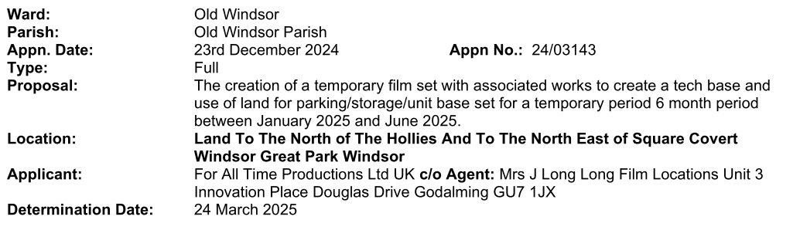
Members had NO OBJECTION to this application.

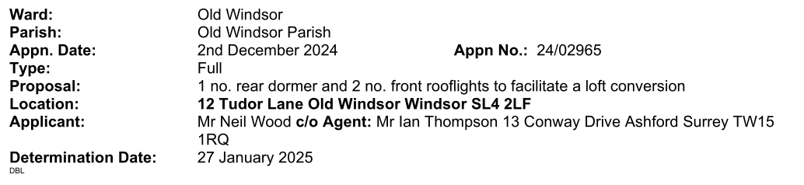
There is no information provided as to the amount of parking available for this 5 bedroom property and if it is sufficient. Members have NO OBJECTION is it meets the requirements but if it doesn’t then they will have an OBJECTION to it for that reason.

Appn. Date: | 3 January 2025 | Appn. No.: | 25/00003
Type: | Full
Proposal: | Two storey wraparound extension (front/side/rear), front canopy, raising of the eaves and ridge, loft conversion, 3no. front gable features and alterations to fenestration, following demolition of existing elements.
Location: | 67 Burfield Road Old Windsor Windsor SL4 2LN
Parish/Ward: | Old Windsor Parish/Old Windsor
Applicant: | Mr And Mrs Paul Jackson
Agent: | Mr Ian Benbow Ian Benbow, RIBA Chartered Architect 12 Meadow Close Old Windsor Slough SL4 2PB email: benbowis@btinternet.com tel: 07890951987

Members had concerns that this is a highways safety issue as all four parking spaces are controlled by one vehicle meaning that if that vehicle in the Car 2 spot, and is not being used, then it has to be moved to let any of the others out whilst being close to a blind bend.

-2-

104.24 CHAIRMANS REPORT
The Chair updated members on progress following the Wellness event in October 2024. Members were also informed about a homeless man living in a tent on Church Road. He is in good health and in communication with all the relevant authorities.

105.24 BOROUGH COUNCILLORS REPORTS
Cllr. Jones updated members about the current situation at RBWM.

106.24 COUNCILLORS REPORTS, QUESTIONS AND COMMENTS
Cllr. Beer informed members that Heathrow is starting up again with its expansion plans.

107.24 NEXT MEETING
The next Meeting of the Council will be held at the Parish Meeting Room on the
12th February 2025 at 7.30pm.

________________________ CHAIRMAN
THE MEETING CLOSED AT 9.15pm

-3-

